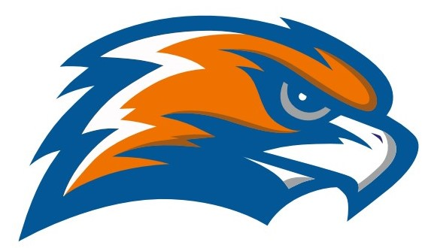

| **GARRETT MORGAN WOMEN’S BASKETBALL Senate - Erie Division 2021-2022** |
| --- |

Head Coach Robert Cecil Assistant Coach Christian Shearer

Principal GMSEI Quenton Davis Principal GMSLI Anshawn Ivery

Athletic Director Jennifer Smith

| **DATE** | **TIME** | **VISITOR** | **HOME** | **SITE** |
| --- | --- | --- | --- | --- |
| **Saturday**  **11/20** | **7:45 V** | **Garrett Morgan** | **Cleveland Heights** | **Cleveland Heights** |
| **Tuesday**  **11/30** | **7:00 V** | **Garrett Morgan** | **John F Kennedy** | **John F Kennedy** |
| **Friday**  **12/3** | **7:00 V** | **Collinwood** | **Garrett Morgan** | **Garrett Morgan** |
| **Tuesday**  **12/7** | **7:00 V** | **Lincoln West** | **Garrett Morgan** | **Garrett Morgan** |
| **Friday**  **12/10** | **7:00 V** | **Campus International** | **Garrett Morgan** | **Garrett Morgan** |
| **Monday**  **12/13** | **6:00 V** | **Garrett Morgan** | **Brookside** | **Brookside** |
| **Tuesday**  **12/14** | **7:00 V** | **Garrett Morgan** | **Max Hayes** | **Max Hayes** |
| **Friday**  **12/17** | **5:00 V** | **Garrett Morgan**  **(independent)** | **John Adams** | **John Adams** |
| **Monday**  **12/20** | **6:00 V** | **Garrett Morgan** | **Clearview** | **Lorain Clearview** |
| **Wednesday**  **12/22** | **5:15 V** | **Garrett Morgan** | **Fuchs Mizrachi A** | **Fuchs Mizrachi** |
| **Tuesday**  **12/28** | **5:15 V** | **Garrett Morgan** | **Fuchs Mizrachi B** | **Fuchs Mizrachi** |
| **Friday**  **1/7** | **7:00 V** | **John F Kennedy** | **Garrett Morgan** | **Garrett Morgan** |
| **Tuesday**  **1/11** | **7:00 V** | **Garrett Morgan** | **Collinwood** | **James F Rhodes** |
| **Friday**  **1/14** | **5:30 JV**  **7:00 V** | **Garrett Morgan** | **Lincoln West** | **Lincoln West** |
| **Tuesday**  **1/18** | **5:30 JV**  **7:00 V** | **Garrett Morgan** | **Campus International** | **Wilson** |
| **Friday**  **1/21** | **5:30 JV**  **7:00 V** | **Max Hayes** | **Garrett Morgan** | **Garrett Morgan** |

**ERIE DIVISION SENATE CHAMPIONSHIP GAME**

**Tuesday February 8 @ 5:45**

**Rocket Mortgage Field House**

**OHSAA SECTIONALS - February 7 - 19 TBA**

**Senate Athletic League - Erie Division**

**Campus International Collinwood Garrett Morgan John F Kennedy Lincoln West Max Hayes**